WEB DEVELOPMENT

ACTIVITY-BASED LEARNING

Submitted by: Garapati Abhilash

Course: B.Tech – Artificial Intelligence and Machine Learning

Projects:

1. Doctor Appointment Website
2. Tourism Website
3 .Online News Portal Website

1. Doctor Appointment Website
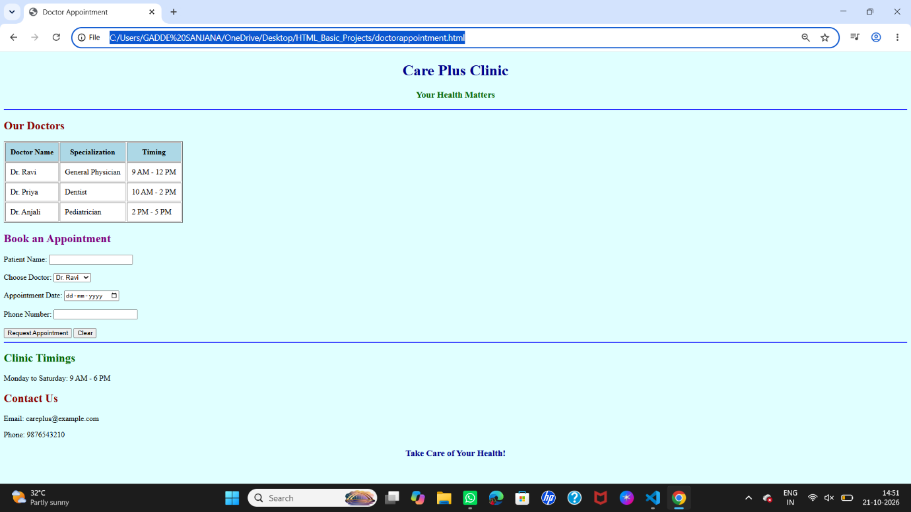

2. Tourism Website
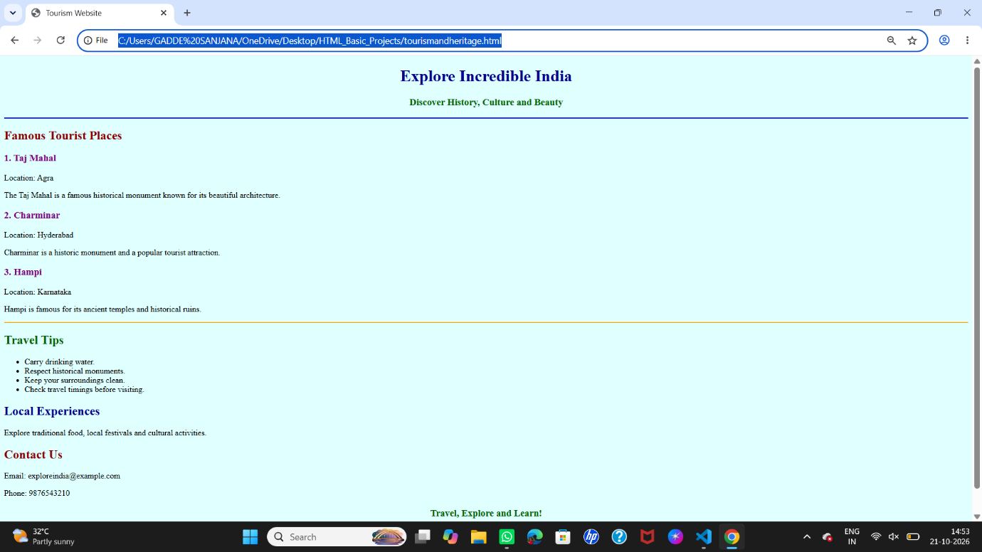

3.Online News Portal Website


